CLAUSES CLAUSES
1. Complete each sentence with two to five words, including the one in bold.  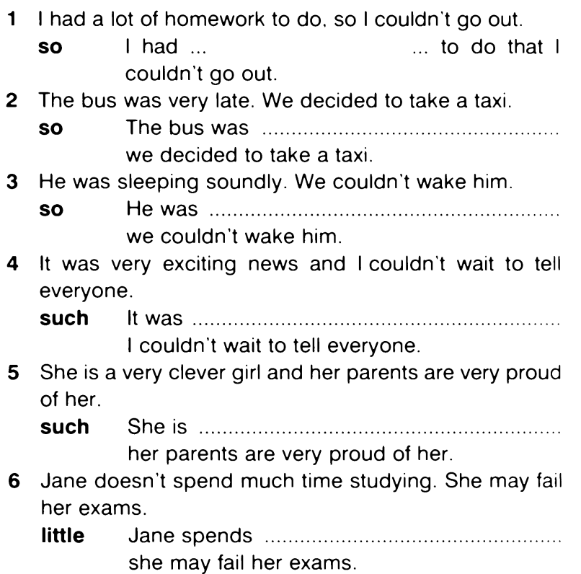  2. Join the sentences using the conjunction in brackets.  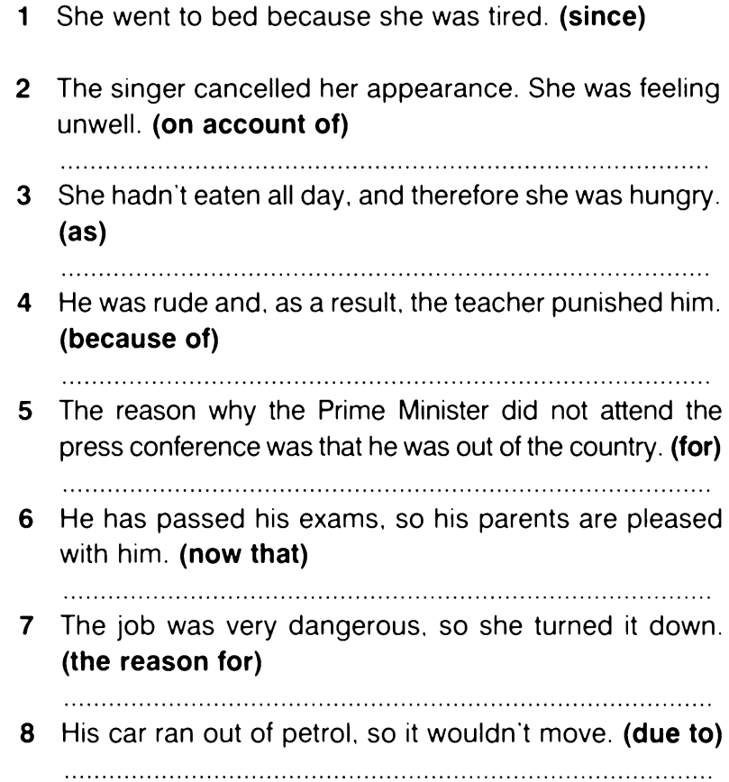  3. Complete each sentence with two to five words, including the one in bold.  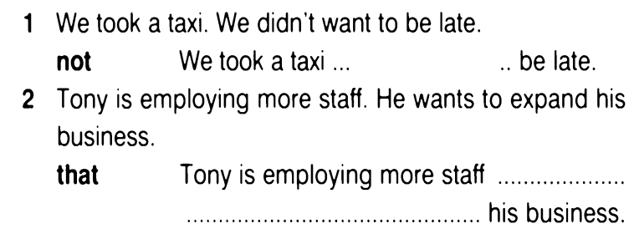  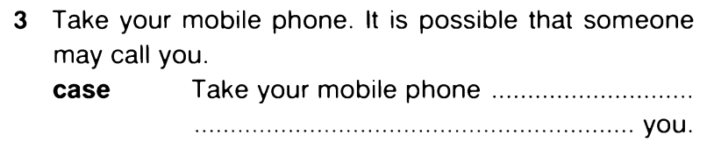  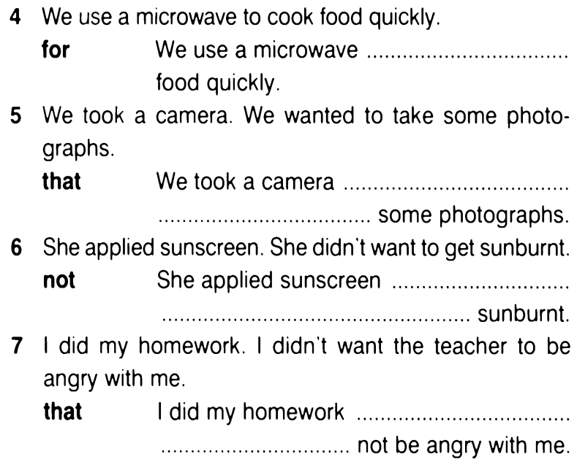  4. Complete the sentences.  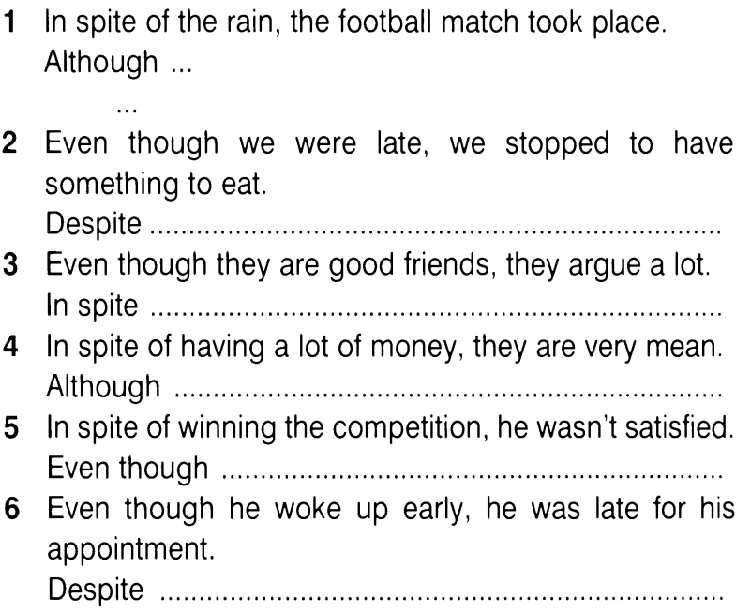  5. Put the verbs in brackets in the correct form.  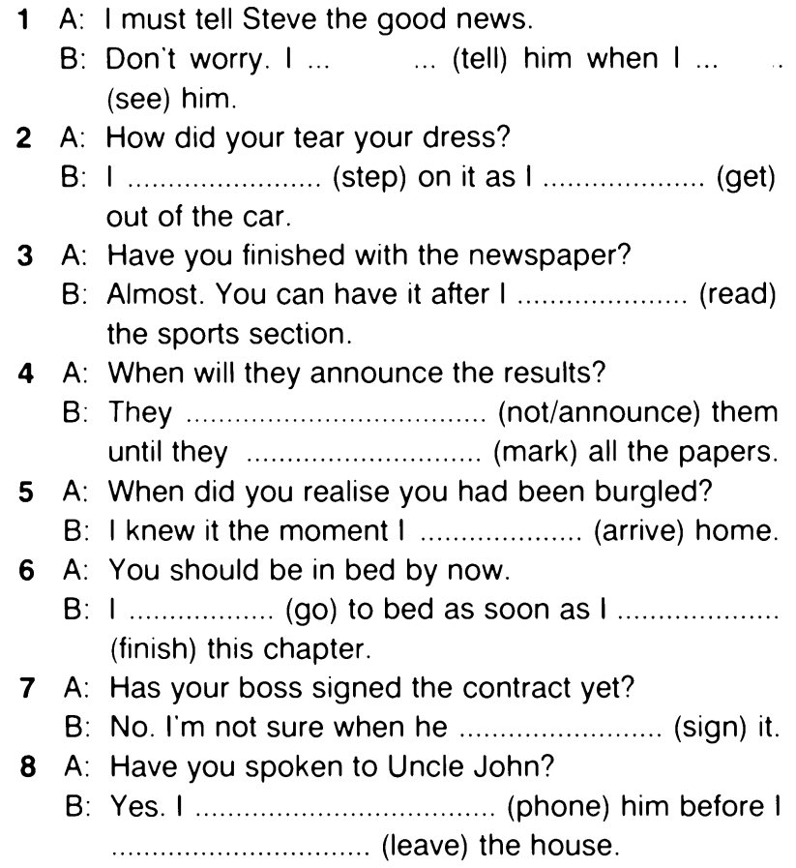 | 1. Complete each sentence with two to five words, including the one in bold.  2. Join the sentences using the conjunction in brackets.  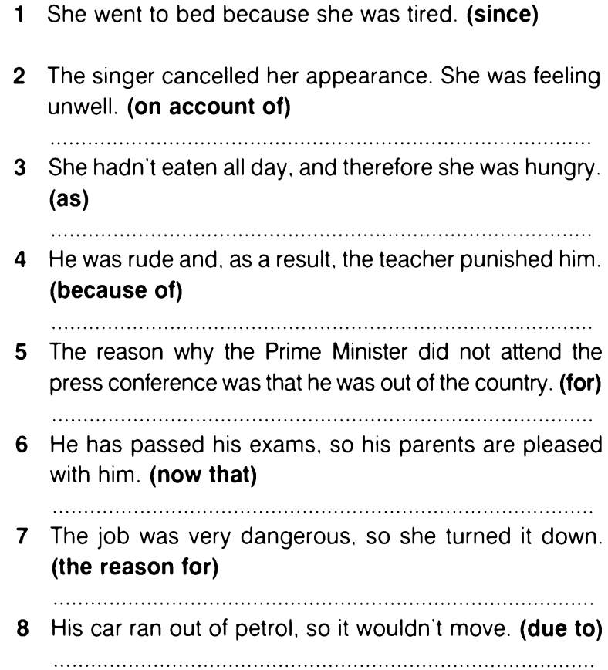  3. Complete each sentence with two to five words, including the one in bold.  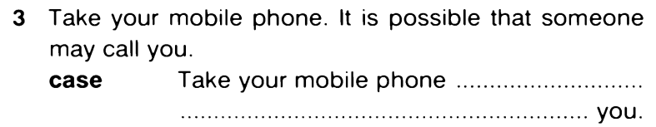  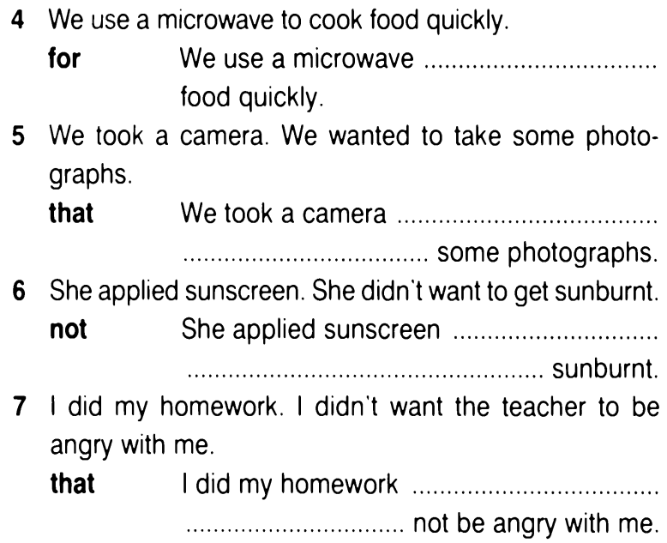  4. Complete the sentences.  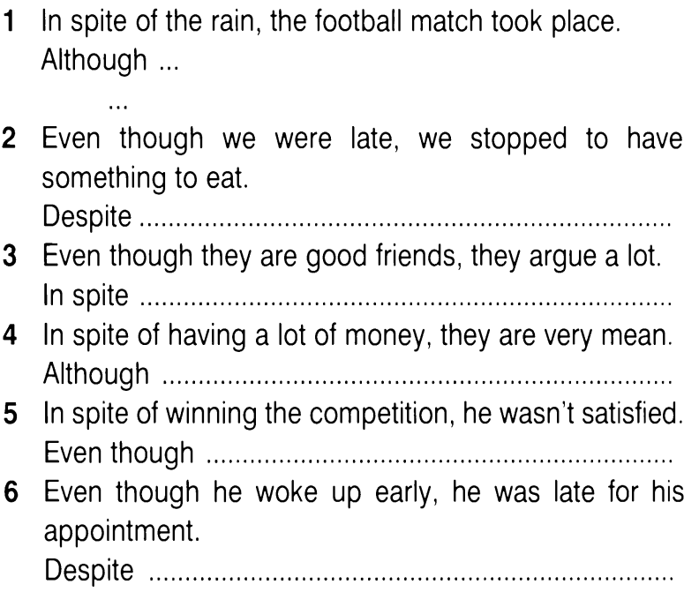  5. Put the verbs in brackets in the correct form.  