Comparisons
1. Fill in the gaps with the correct comparative/superlative form.  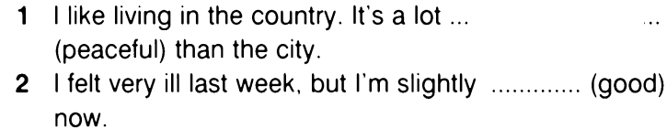  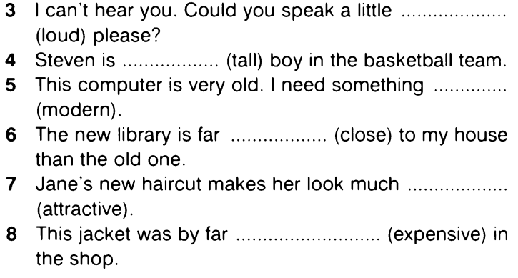 | 2. Fill in the gaps with your own ideas and the correct form of the adjective/adverb.  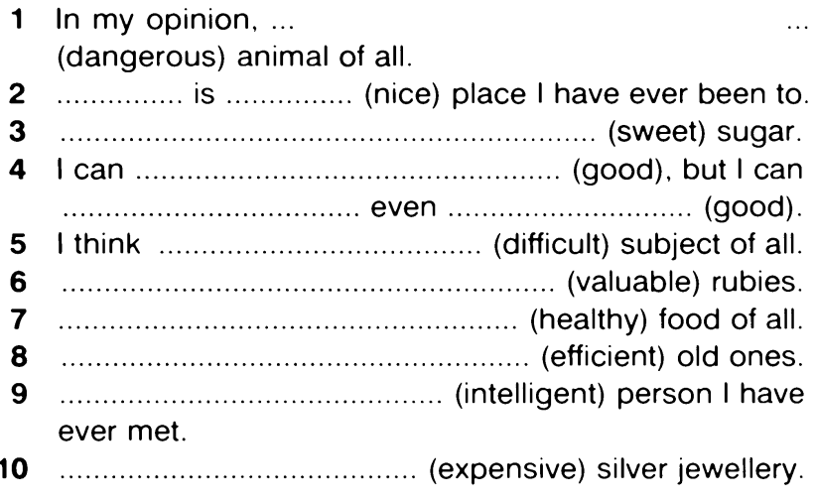
3. Use the correct comparative structures to complete the sentences.  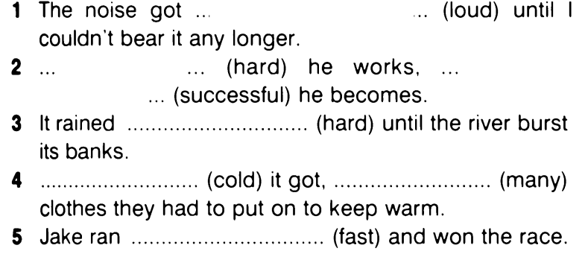 | 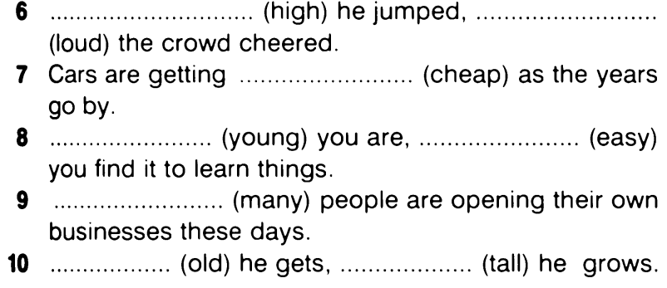

Comparisons
1. Fill in the gaps with the correct comparative/superlative form. | 2. Fill in the gaps with your own ideas and the correct form of the adjective/adverb.
3. Use the correct comparative structures to complete the sentences.

4. Cross out the unnecessary word.  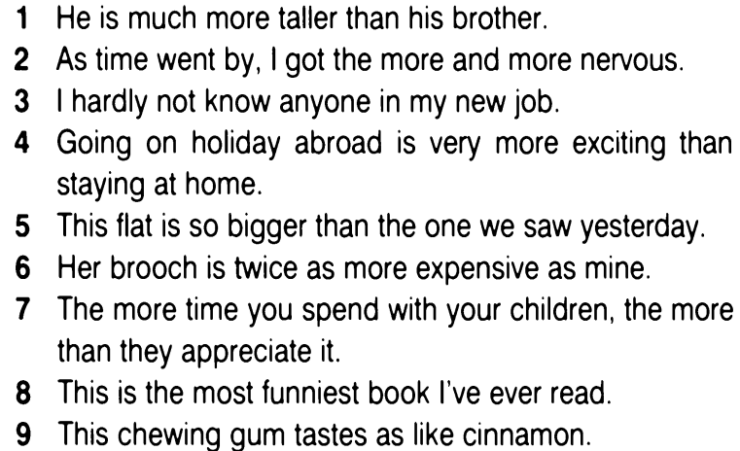 | 5. Correct the mistakes.  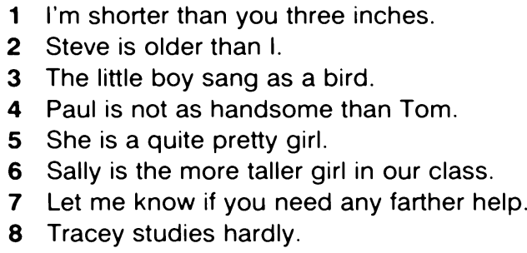  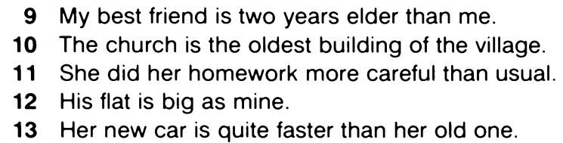
6. Fill in the correct form of the verb.  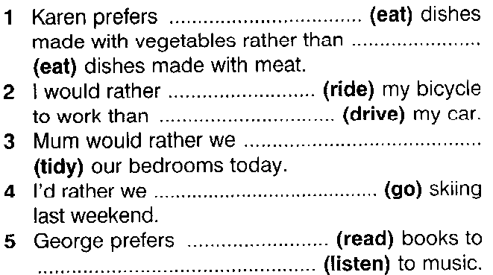 | 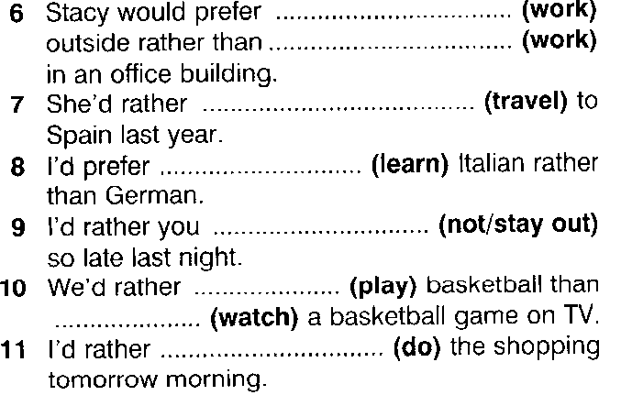

4. Cross out the unnecessary word.  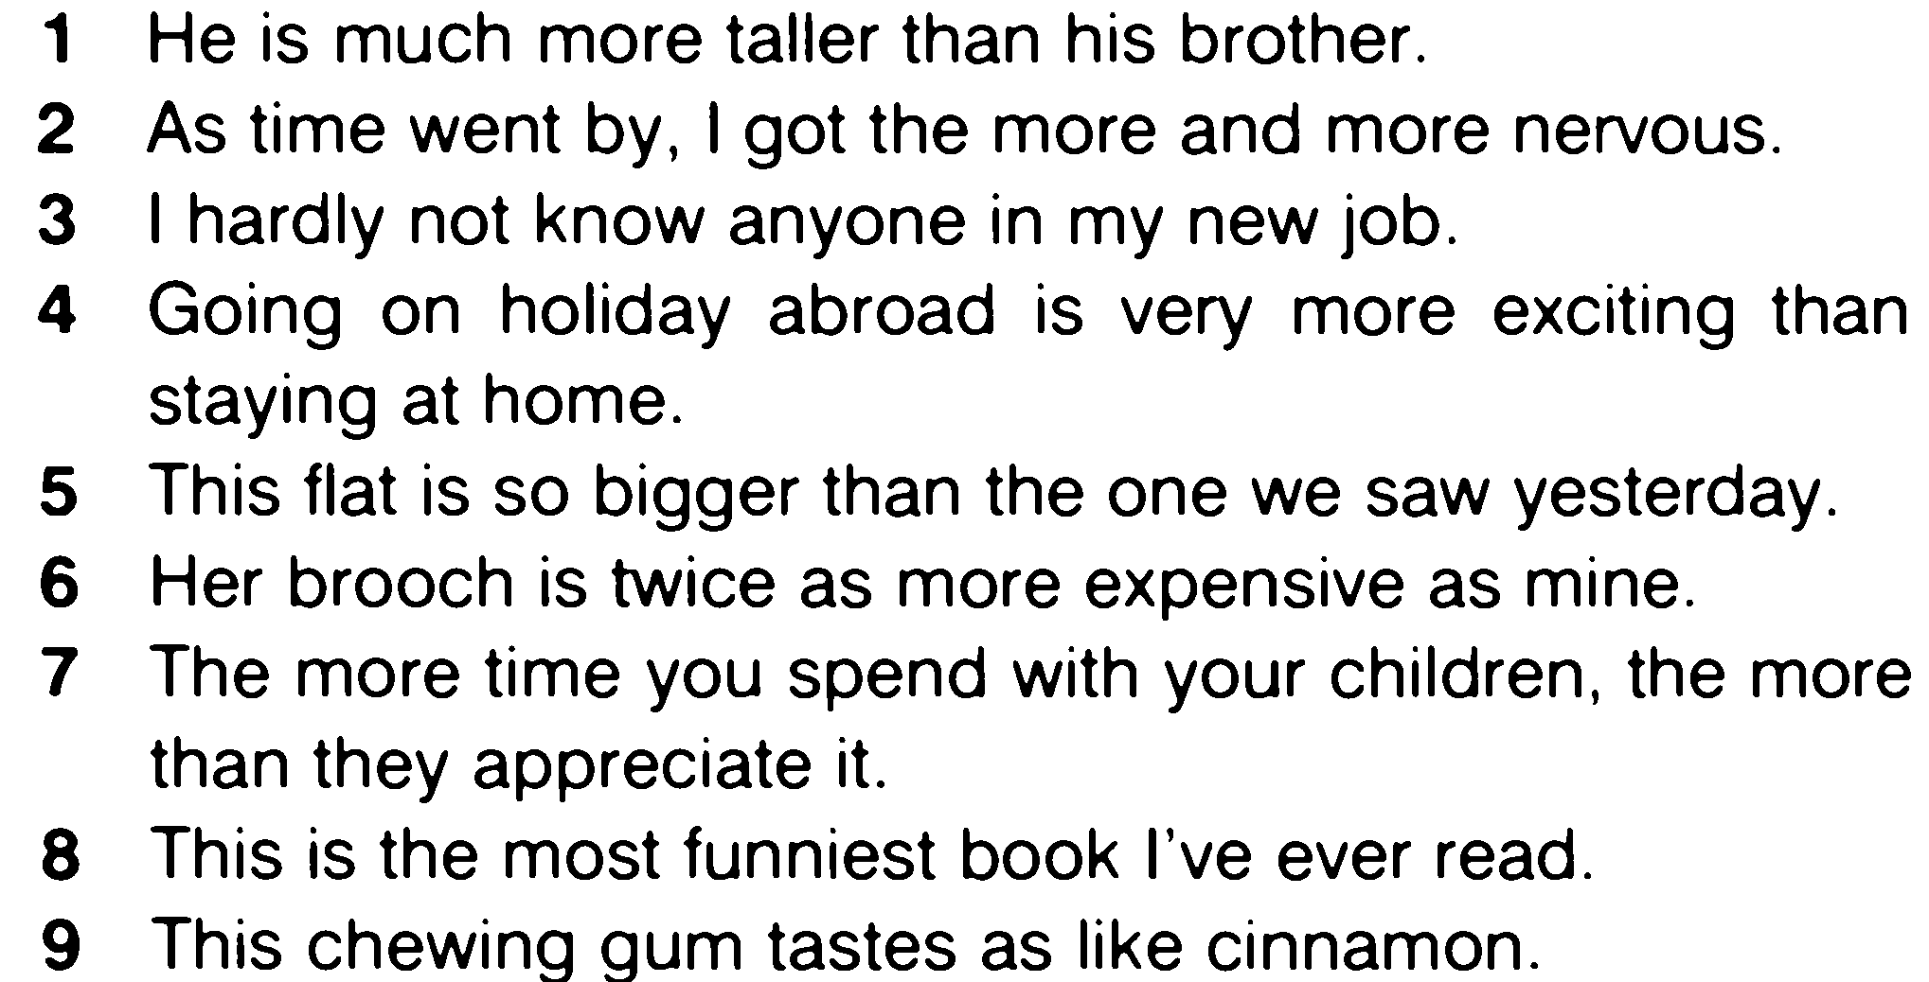 | 5. Correct the mistakes.  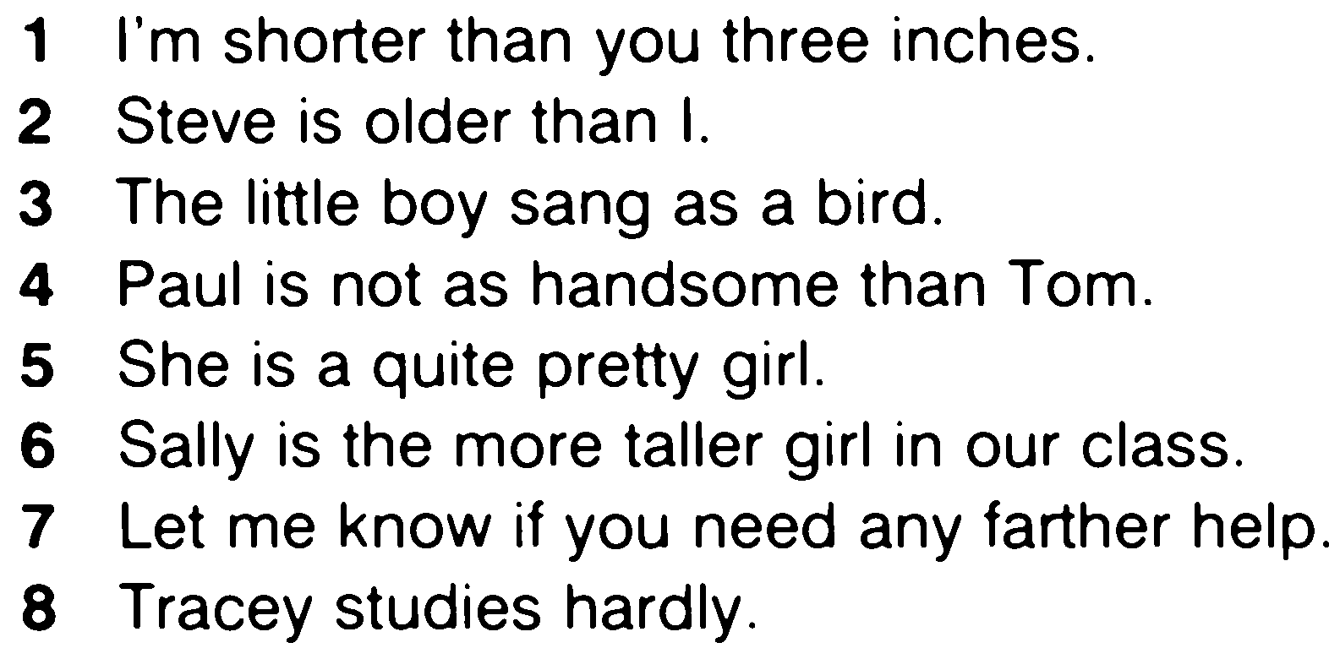  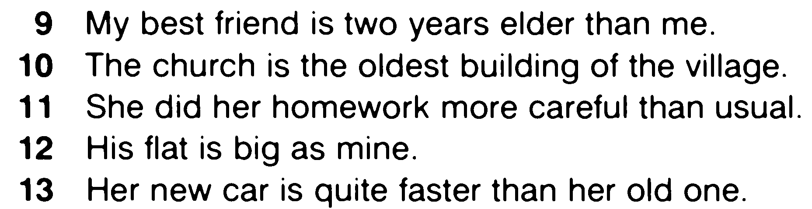
6. Fill in the correct form of the verb.

